Y.M.I.R: Yielding MELODIES FOR INTERNAL RESTORATION

A PROJECT REPORT

BY

TEAM NO. 04

TEAM MEMBER1 (E23CSEU0022)

TEAM MEMBER2 (E23CSEU0014)

SUBMITTED TO

SCHOOL OF COMPUTER SCIENCE ENGINEERING AND TECHNOLOGY, BENNETT UNIVERSITY

GREATER NOIDA, 201310, UTTAR PRADESH, INDIA

April 2025

# DECLARATION

We hereby declare that the work which is being presented in the report entitled “**Y.M.I.R**.”, is an authentic record of our own work carried out during the period from January 2025 to April 2025 at School of Computer Science and Engineering and Technology, Bennett University Greater Noida.

The matters and the results presented in this report has not been submitted by me/us for the award of any other degree elsewhere.

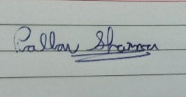

Pallav Sharma

(Enroll. No. E23CSEU0022)

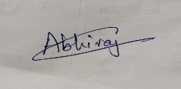

Abhiraj Ghose

(Enroll. No. E23CSEU0014)

# ACKNOWLEDGEMENT

I/We would like to take this opportunity to express my/our deepest gratitude to my/our mentor, **Dr. Rishi Dutt Sharma** for guiding, supporting, and helping me/us in every possible way. I/we was/were extremely fortunate to have him as my/our mentor as he provided insightful solutions to problems faced by me/us thus contributing immensely towards the completion of this capstone project. I/We would also like to express my/our deepest gratitude to VC, DEAN, HOD, faculty members and friends who helped me/us in successful completion of this capstone project.



Pallav Sharma

(Enroll. No. E23CSEU0022)



Abhiraj Ghose

(Enroll. No. E23CSEU0014)

**TABLE OF CONTENTS**

LIST OF TABLES vi

LIST OF FIGURES vii

LIST OF ABBREVIATIONS viii

ABSTRACT ix

1. INTRODUCTION 1

1.1. Problem Statement 1

2. Background Research 2

2.1. Proposed System 2

2.2. Goals and Objectives 2

3. Project Planning 3

3.1. Project Lifecycle 3

3.2. Project Setup 3

3.3. Stakeholders 4

3.4. Project Resources 4

3.5. Assumptions 5

4. Project Tracking 5

4.1. Tracking 5

4.2. Communication Plan 6

4.3. Deliverables 7

5. SYSTEM ANALYSIS AND DESIGN 8

5.1. Overall Description 8

5.2. Users and Roles 8

5.3. Design diagrams/ UML diagrams/ Flow Charts/ E-R diagrams 9

5.3.1. Use Case Diagrams 9

5.3.2. Class Diagram 10

5.3.3. Activity Diagrams 11

5.3.4. Sequence Diagram 12

5.3.5. Data Architecture 13

6. User Interface 14

6.1. UI Description 14

6.2. UI Mockup 14

7. Algorithms/Pseudo Code 15

8. Project Closure 16

8.1. Goals / Vision 16

8.2. Delivered Solution 16

8.3. Remaining Work 16

REFERENCES 17

LIST OF TABLES

Table Page

Table 1: Goal and Objectives 2

Table 2: Sample 2 3

Table 3: Sample 3 4

Table 4: Sample 4 4

Table 5: Sample 4 5

Table 6: Sample 6 5

Table 7: Regularly Scheduled Meetings 6

Table 8: Information To Be Shared Within Our Group 6

Table 9: Information To Be Provided To Other Groups 6

Table 10: Information Needed From Other Groups 7

Table 11: Deliverables 7

Table 12: Sample 12 8

LIST OF FIGURES

Figure Page

Figure 1: Sample use-case diagram 9

Figure 2: sample 2 11

Figure 3: sample 3 12

Figure 4: Sample 4 13

Figure 5: Sample 5 13

Figure 6: Sample 6 14

LIST OF ABBREVIATIONS

**AI Artificial Intelligence**

**YMIR Yielding Melodies for Internal Restoration**

**NLP Natural Language Processing**

**FER Facial Emotion Recognition**

**BERT   Bidirectional Encoder Representations from Transformers**

**CNN Convolutional Neural Network**

**CSV Comma‑Separated Values**

**PEP8 Python Enhancement Proposal 8**

**E‑R Entity‑Relationship**

**UML Unified Modeling Language**

**SDLC Software Development Lifecycle**

**UI User Interface**

**CI Continuous Integration**

**API Application Programming Interface**

**CPU Central Processing Unit**

**OS Operating System**

**GPU Graphics Processing Unit**

ABSTRACT

The modern digital era has exposed the current generation to growing challenges regarding their emotional well-being through stressful environments, increasing social anxiety due to excessive technology usage. The field of AI has achieved numerous accomplishments yet there aren’t any complete developed systems capable of emotional user interaction with emotion detection abilities. Using both emotional cues present in facial expressions and text chat, **Y.M.I.R** creates an advanced **AI** system which then suggests suitable music across various contexts for mood improvement.

The system combines **FER** using DeepFace (Python’s language inbuilt library) with **NLP** implementing **TextBlob [13]** and **BERT [12]** models for effective text-based emotion detection. Real-time emotion detection takes place through the webcam and chatbot interface of a Flask-based web application which operates two parallel tracking techniques. The system computes final dominant emotions using a combination of data from facial expressions and text analysis in real-time by either selecting results from confident sources or computing weighted averages.

Based on the determined final emotional state, a **content-based music recommendation engine** is used which is trained on a dataset scraped directly from **Spotify** with over 1000 records, that includes mood tags, mental health benefits, and audio features and incorporated ensemble learning to make predictions for recommending music. This system presents users with songs either matching their current mood selection or it provides optimistic audio content to positively influence their emotional states. The music application displays a mini-player that resembles the format used by **Spotify** along with other commercial platforms for smooth listening control.[15]

This project demonstrates how the union of **Artificial Intelligence** can enable linking of emotional intelligence with customised personal well-being offerings between human and machines. The system employs real-time intelligence together with offline functionality to deliver music therapy as a mental health promotion through machine learning and user-centred design.

1. INTRODUCTION

Music is acknowledged across various sectors as an effective instrument that can modulate the feelings, as even therapists have adopted it as a means to promote mood pattern helping their patients. The leading method used by successful computing systems is facial recognition or text written analysis leading to lower accuracy of emotion perception. The realization of cloud-based models involves three significant disadvantages since it compromises privacy levels, increases performance slowness, while also reducing the system accessibility. Such offline system requires to be created that shortly accomplishes through multiple data sources to gauge emotions and generates corresponding responses in the form of mood-based song suggestions. The **multi-modal AI** platform of **Y.M.I.R** includes facial and text-based emotion recognition to attain a full range of emotional states of users. Users can obtain emotion-driven recommendations through music using Flask, which is done based on their scanned emotions and supports platform offline.

**Key Motivations:**

* Growing demand for **AI** systems that go beyond utility to address emotional well-being.
* The gap in current technologies in detecting and responding to complex human emotions.
* An interest in the field of mental health and music.
  1. Problem Statement

Most AI systems recognize emotions by a single stimulation source like facial expressions and texts, but cannot provide an emotionally sensitive response. Popular music recommendation services like Spotify, Amazon Music and many other try to recommend songs on the foundation of user history or style but they neglect to take into consideration live emotional states. These limitations lead to emotionally cools user- experiences. System developers should devise one universally standardized platform which will be able to read real-time emotion shifting from face and writing data to produce music which is to the liking of the user based on his emotions. This system reaches mental wellness goals.

1. Background Research

The integration of **AI** into music recommendation systems has opened new avenues for enhancing user experience by aligning musical suggestions with users' emotional states. Traditional recommendation systems primarily rely on user preferences and listening history, often neglecting the real-time emotional context of the user. Recent research endeavors have focused on developing systems that can detect user emotions and recommend music accordingly, aiming to provide a more personalized and emotionally resonant listening experience.[4][14]

The study by Mahadik et al. (2021) presents a mood-based music player that performs real-time mood detection using facial expressions and suggests songs that correspond to the detected mood. The system employs image analysis to predict user expressions and recommends music that aligns with the user's current emotional state, thereby enhancing user satisfaction and engagement.[1]

Source:<https://www.researchgate.net/publication/352780489_Mood_based_music_recommendation_system>

<https://blog.emb.global/ai-in-music-composition-and-production/>

Similarly, the research published in the International Journal of Engineering Research & Technology (IJERT) discusses a system that analyzes the user's image to predict expressions and suggest suitable songs. This approach emphasizes the significance of incorporating mood detection into music players to improve user experience.[2]

Source: <https://www.ijert.org/mood-based-music-recommendation-system>

Another study, available through IRJET, introduces a mood-sensitive music recommendation system that utilizes real-time facial emotion analysis to generate personalized music playlists. The system uses pre-trained convolutional neural networks (**CNN**s) for feature extraction and employs categorical cross-entropy loss functions to address dataset imbalances. By analyzing facial emotions, the system aims to enhance user experience by automating music recommendations based on emotional states.[3]

Source: <https://www.irjet.net/archives/V10/i8/IRJET-V10I871.pdf>

These systems showcase a move towards more emotionally intelligent computing environments, emphasizing that emotional state detection can significantly enhance personalized recommendations. Each of these studies recognizes the importance of integrating emotion analysis into user interaction, particularly for entertainment and mental health applications.[6] [7]

While facial expression analysis is a powerful tool for detecting mood, it may not always accurately reflect the user's internal state. Contextual emotion analysis through chat or typed inputs can capture more nuanced emotional expressions. Some recent systems attempt to incorporate text analysis, but they often lack the depth or real-time capability needed for dynamic applications.

Text-based emotion detection involves natural language processing techniques that assess sentiment and emotional tone from written language. When combined with visual cues, it provides a more robust and accurate emotional profile. This multi-modal approach is a key innovation direction for emotion-aware systems and lays the foundation for projects like **Y.M.I.R**.

**Limitations of Existing Systems:** While these systems represent significant advancements in mood-based music recommendation, they exhibit certain limitations:

• Most systems rely solely on facial expression analysis, potentially overlooking the nuanced emotional cues present in textual communication.

• Many existing models are cloud-based, raising concerns about data privacy, latency, and accessibility in offline scenarios.

• The emotional categories recognized by these systems are often restricted to basic emotions, which may not capture the complexity of human affective states.

• There is a lack of personalization in the recommendation logic, as most systems match songs based on generic mood labels instead of personalized emotional patterns.

**Motivation for Y.M.I.R.**

The identified limitations in current systems underscore the need for a more comprehensive approach to emotion-based music recommendation. Y.M.I.R. aims to address these gaps by:

• Combining facial expression analysis with text-based sentiment analysis to capture a broader spectrum of emotional cues.

• Developing an offline-capable system to ensure user privacy and accessibility without reliance on internet connectivity.

• Incorporating advanced AI models to recognize a wider range of emotions, facilitating more accurate and personalized music recommendations.

• Using music not only to reflect current moods but to actively uplift users' emotional states, contributing to emotional resilience and mental wellness.

By integrating these features, Y.M.I.R. aspires to create an empathetic AI companion that not only understands the user's emotional state but also actively contributes to emotional well-being through tailored music suggestions.

* 1. Proposed System

This project is designed to boost emotional well-being by creating intelligent, multi-modal system that in real-time detect user's emotional condition from facial expressions and textual communication and responds by advice emotionally right music. So, by the use of the AI, the ML and the AC the system trying to mimic a human like emotions and an emotional type response meaning and provide it beyond the rule the based user interface.

Using advanced facial emotion recognition (FER) algorithms, natural language processing (NLP), and a locally hosted AI chatbot, the system collects emotional cues from both webcam input and user conversations. These emotion readings are then aggregated, analysed, and used to compute a final dominant emotional state. Based on this emotion, the system triggers a content-based filtering model to recommend songs that either reflect the user’s mood or uplift them if the emotion is negative.[9]

The concept behind this system is to build up an interactive AI companion that not only chats with individuals but recognizes and cooperates with their mental condition generally also amid troublesome mental minutes. Where Mental Health tools are unaffordable or unfeeling, PAD provides a digital solution that is fast to respond and help, empathetic, real time and respectful by nature.

This system will bring joy into users' daily lives with a calming or uplifting musical intervention fitted to their emotional state. As part of continuous research to integrate AI with emotional intelligence, Y.M.I.R. brings a very individualized and off the net approach for emotional reparation through music—a field missing in AI propelled recommendation engines.

2.2 Goals and Objectives

The primary goal of the Y.M.I.R. project is to develop a real-time, offline-capable, multi-modal AI system that accurately detects human emotions through both facial and textual inputs and responds with personalized music recommendations aimed at emotional restoration.

Table : Goal and Objectives

|  |  |
| --- | --- |
| **#** | **Goals or Objectives** |
| 1 | |  | | --- | | Integrate facial emotion recognition using DeepFace into a real-time web interface. |  |  | | --- | |  | |
| 2 | |  | | --- | | Develop a text-based emotion detection module using NLP models such as BERT, TextBlob, and GPT4All. |  |  | | --- | |  | |
| 3 | Implement a hybrid emotion aggregation algorithm to compute a final dominant emotion from both inputs. |
| 4 | Build a content-based music recommendation engine using features such as mood labels and mental health benefits. |
| 5 | Design and deploy a responsive, user-friendly web UI with video feed, chatbot interface, and embedded music player. |
| 6 | Ensure complete offline functionality, using open-source models for privacy and accessibility. |
| 7 | Log emotion data and provide periodic summaries for insights and mood tracking. |
| 8 | Conduct internal user testing to evaluate emotional accuracy and musical relevance with at least 80% satisfaction rate. |
| 9 | Provide meaningful documentation for system architecture, user guidance, and technical configuration. |
| 10 | Maintain teamwork through agile development (SCRUM) with weekly sprint reviews and version-controlled development (Git). |
| 11 | Have fun working on the project |

1. Project Planning

This section outlines the structured approach taken to plan and implement the Y.M.I.R system. The planning involved selecting a suitable development lifecycle, identifying key stakeholders, determining necessary resources, and documenting any assumptions that guided the project’s progress.

* 1. Project Lifecycle

Given the iterative nature of the system's design — including continuous refinement of the emotion detection models and integration of new recommendation logic — the **Agile Software Development Lifecycle (SDLC)** was chosen. Agile allows for flexibility, adaptability to feedback, and incremental delivery of key components. Development was split into the following major sprints:[16]

* **Sprint 1:** Research, dataset preparation, and emotion detection setup using DeepFace.
* **Sprint 2:** Integration of text-based emotion classification through chatbot conversation.
* **Sprint 3:** Development of music recommendation engine using content-based filtering.
* **Sprint 4:** Flask-based full stack integration with a modern frontend UI.
* **Sprint 5:** Emotion averaging logic, background processing, and UI enhancements (e.g., animated elements, floating player).
* **Sprint 6:** Final testing, optimization, and documentation.

Each sprint involved planning, development, testing, and review, which allowed continuous user-focused improvement of the system.

.

* 1. Project Setup

The following decisions were made during the initial setup of the project. These decisions guided the project's direction, tooling, standards, and deployment strategy.

Table : Sample 2

|  |  |
| --- | --- |
| **#** | **Decision Description** |
| 1 | **Operating System:** Windows 11 Home with Python 3.10; **Development Stack:** Flask, HTML/CSS, JavaScript;  **AI Frameworks:** DeepFace for FER, scikit-learn for text emotion classification;  **Version Control:** Git and GitHub. |
| 2 | Followed **PEP8 Python coding standards**, organized modular architecture, and adhered to best practices in HTML/CSS design. Emotion detection modules and chatbot logic were separated for maintainability. |
| 3 | |  | | --- | | No external cloud APIs were used to preserve user privacy; project runs entirely offline. No special access or licenses required. The final project can be released as open source. | |
| 4 | |  | | --- | |  |  |  | | --- | | The system was developed and tested on a local machine simulating real-world usage conditions (webcam input, offline processing, browser interaction). Deployment on Flask ensured environment portability. | |

* 1. Stakeholders

The stakeholders involved in this project include:

Table : Sample 3

|  |  |
| --- | --- |
| **Stakeholder** | **Role** |
| Person A | Indirect User [Family Members] |
| Person B | Dr. Rishi Datt [ Mentor] |
| Person C | Dr. Rishi Datt [ Instructor] |
| Person D | Pallav Sharma [Project developer] |
| Person E | Abhiraj Ghose [Project developer] |

* 1. Project Resources

To ensure successful development and working, the following resources were utilized:

**Example:**

Table : Sample 4

|  |  |  |
| --- | --- | --- |
| **Resource** | **Resource Description** | **Quantity** |
| Hardware: | Laptop with Intel i7 CPU, 16GB RAM, and NVIDIA RTX 4060 GPU for local development and model inference. | 2 |
| Capstone Team | Our team of students who will be the primary developers of the project. | 2 |
| Dr Rishi Datt [Mentor] | The mentor who will be able to provide us with technical assistance. | 1 |
| Python Libraries | OpenCV, DeepFace, scikit-learn, Flask, transformers, etc., used for development. | - |
| External Monitor | Used for extended workspace during UI/UX and video-based model testing. | 1 |
| Dataset | Pre-cleaned CSV dataset with Mood Labels, Mental Health Benefits, and Musical Features for training the recommendation engine. | 1 |
| |  | | --- | | **Browser** |  |  | | --- | |  | | Google Chrome for testing and rendering the real-time web-based system UI. | 1 |

* 1. Assumptions

The following assumptions have been made during the course of the project to plan development, resourcing, and delivery timelines effectively:

Table : Sample 4

|  |  |
| --- | --- |
| **#** | **Assumption** |
| A1 | The project team and mentor will be able to meet regularly (virtually or physically) once a week. |
| A2 | |  | | --- | |  |  |  | | --- | | All required Python libraries and frameworks (e.g., DeepFace, Flask, Transformers) will remain open-source and stable during the development period. | |
| A3 | The team will have uninterrupted access to the development laptop with GPU support throughout the project. |
| A4 | Team will have sufficient time to complete a working model to present by mid-semester |
| A5 | Internet access will be available during testing phases that require fetching online content (e.g., YouTube/Spotify embeds). |
| A6 | The development test data provided will be sufficient to create an accurate prediction of user actions |
| A7 | Users interacting with the system will do so under reasonably controlled lighting and positioning for FER accuracy. |
| A8 | All planned features (FER, chatbot, music recommendation, UI components) can be integrated into a single Flask web application. |
| A9 | The models developed will be easily extended to other forms within the time frame |

1. Project Tracking
   1. Tracking

The development of the Y.M.I.R. project was regularly monitored by use of collaborative tools including version control, documentation, testing and communication. Git and GitHub were employed for storing the source code and keeping track of the version history, while the manual regressions and the code reviews in near-real time enabled to guarantee the reliability of each module. Regular was carried out to update the state of affairs, challenges, and implementation status.

Table : Sample 6

|  |  |  |
| --- | --- | --- |
| **Information** | **Description** | **Link** |
| Code Storage | Project code was stored and managed using Git, with remote access via GitHub. | [Link](http://www.github.com/pallav110/Y.M.I.R) |
| Bug Tracking | Issues and bugs were tracked using Notepad. | N/A |
| Project Documents and Assignments | Weekly updates, diagrams, and progress reports were shared on WhatsApp. | N/A |
| Continuous Integration | Code was manually tested on every feature merge; automated CI was planned but not implemented. | N/A |
| Regression Testing | Manual regression testing was performed at the end of each sprint using test case checklists. | Local testing environment |

* 1. Communication Plan

Effective and regular communication was maintained between team members and the mentor. Weekly meetings, sprint discussions, and on-demand check-ins ensured the team was aligned and issues were promptly addressed.

Table : Regularly Scheduled Meetings

|  |  |  |
| --- | --- | --- |
| Meeting Type | Frequency/Schedule | Who Attends |
| Conference Call | Weekly | Project team and mentor |
| Team Meeting | Weekly | Project team |
| Short Meeting | Weekly in class | Project team |
| Sprint Planning Meeting | Start of each sprint | Project team and mentor |
| Sprint Review Meeting | End of each sprint | Project team, ***mentor, and sponsor*** |

Table : Information to Be Shared Within Our Group

|  |  |  |  |
| --- | --- | --- | --- |
| Who? | What Information? | When? | How? |
| Project team | Task assignments & General scrum information | Weekly | Team meetings, Google Docs, WhatsApp |

Table : Information to Be Provided to Other Groups

|  |  |  |  |
| --- | --- | --- | --- |
| Who? | What Information? | When? | How? |
| Sponsor and mentor | Final deliverables | At completion of project | Project specification doc., code, Power Point presentation |
| Sponsor and mentor | Weekly report | Weekly | Email and Trac site access |
| Mentor | Sprint summaries | At the end of each sprint | Google Docs and verbal update during review. |

Table : Information Needed from Other Groups

|  |  |  |  |
| --- | --- | --- | --- |
| Who? | What Information? | When? | How? |
| Mentor | Feedback and requirement changes | Start of each sprint | Conference call or meeting with sponsor and mentor. |
| Supervisor | Presentation guidelines | Before final submission | Email |

* 1. Deliverables

Below is the list of deliverables planned for successful project execution and evaluation:

Table : Deliverables

|  |  |
| --- | --- |
| **#** | **Deliverable** |
| 1 | Study results (emotion model performance, music impact findings) |
| 2 | Complete codebase (FER, chatbot, music recommender, Flask integration) |
| 3 | Test and test results |
| 4 | Build instructions and configuration files (environment setup) |
| 5 | Installation guide for running the Flask web app offline |
| 6 | User manual for interaction and testing |
| 7 | Postmortem document detailing challenges, resolutions, and team reflections |
| 8 | Final report (final PowerPoint presentation, 3 minute video, and final sprint) |

1. SYSTEM ANALYSIS AND DESIGN

This section describes in detail about the design part of the system.

* 1. Overall Description

The Y.M.I.R. project aims to enhance [human-computer interaction](https://en.wikipedia.org/wiki/Human%E2%80%93computer_interaction) by building a system capable of understanding human emotions through both facial expressions and textual input, and then recommending music that suits or improves the user's emotional state. The system was built with Python as the programming language, key libraries being DeepFace in emotion recognition of facial emotion, NLP models (text-based sentiment analysis and a content base-based music recommender). These are woven into a Flask-based web application with an easy-to-use interface.

The user interacts with the system in real time through web cam feed and chatbot interface. The facial recognition module works with the acquisition of image data on a frame-by-frame basis processing it to detect the present state emotions, and chat bot processes user message to get textual sentiment related to that message and user current feel. Both sources feed into a looming emotion score those changes dramatically over the course of the session. Once processed, an emotion is utilized to query a user created model of songs via cosine similarity, and mood based meta data to receive top music suggestion centred around the aim of emotional uplifting or emotional reinforcement.

The whole process takes place locally which means fully off line functionality as well as data privacy. The UI includes also up-to-date visual elements like animated transitions, floating minimal music player and interactive feedback. The technical design makes the system extendible for future enhancements like voice input, user personalized account, or mood journaling.

* 1. Users and Roles

Table : Sample 12

|  |  |
| --- | --- |
| **User** | **Description** |
| Developer | Responsible for building the facial recognition, chatbot, recommender engine, and UI components. |
| Mentor | Oversees technical guidance, validates implementation, and provides feedback during reviews. |
| System (AI)  General User | Autonomous agent that receives emotion input, processes it, and returns music suggestions   |  | | --- | | Interacts with the camera and chatbot interface; receives music recommendations based on emotions. | |

* 1. Design diagrams/Architecture/ UML diagrams/ Flow Charts/ E-R diagrams
     1. Product Backlog Items
* "As Max, I want to invite my friends, so we can enjoy this service together."
* "As Sasha, I want to organize my work, so I can feel more in control."
* "As a manager, I want to be able to understand my colleagues' progress, so I can better report our success and failures."
* "As a fitness enthusiast, I want to track my workouts and progress in an app so that I can monitor my improvements."
* "As a frequent shopper, I want to save my payment information so that I can check out quickly on future purchases."
* "As an online student, I want to receive notifications for upcoming classes so that I can easily manage my schedule.
  + 1. Architecture Diagram

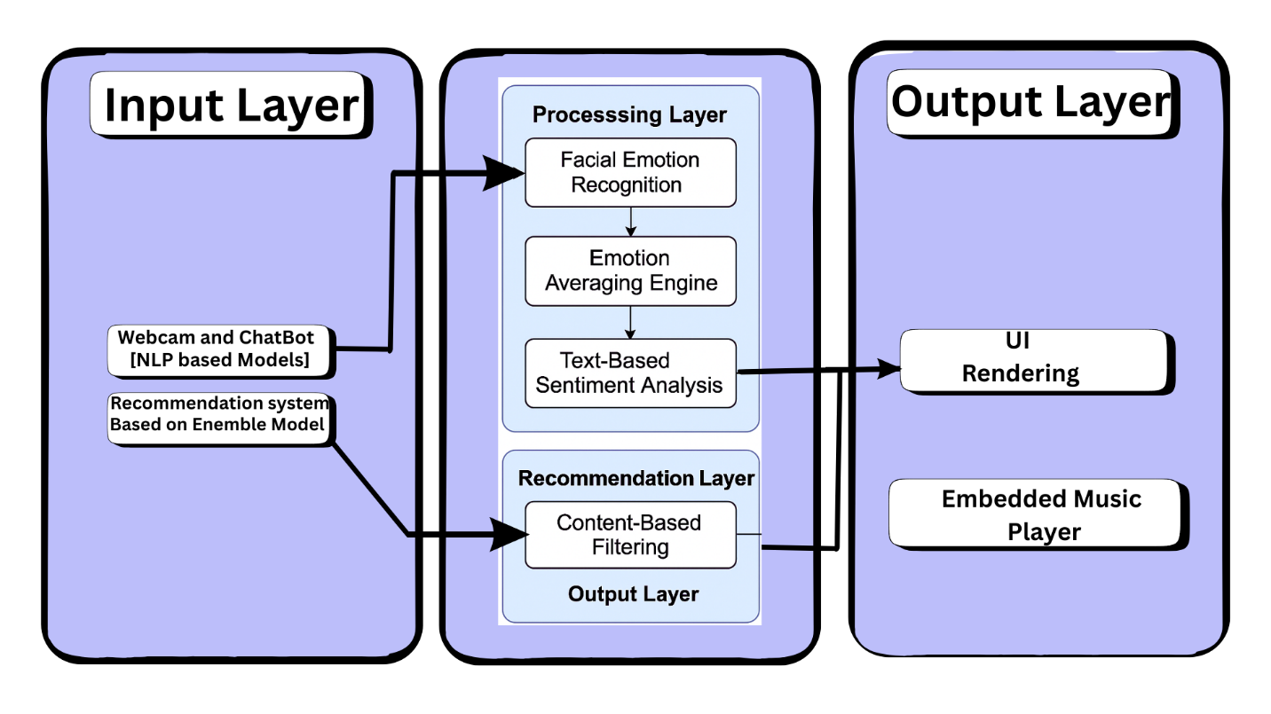

* + 1. 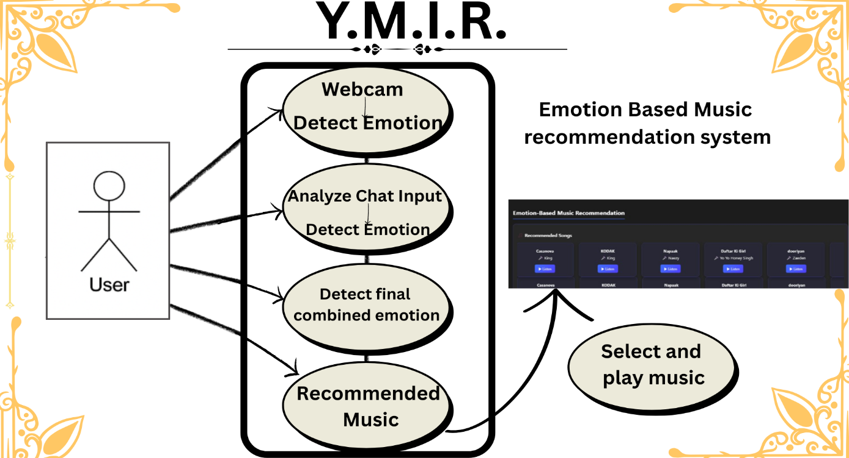Use Case Diagram

Figure : Sample use-case diagram

* + 1. Class Diagram

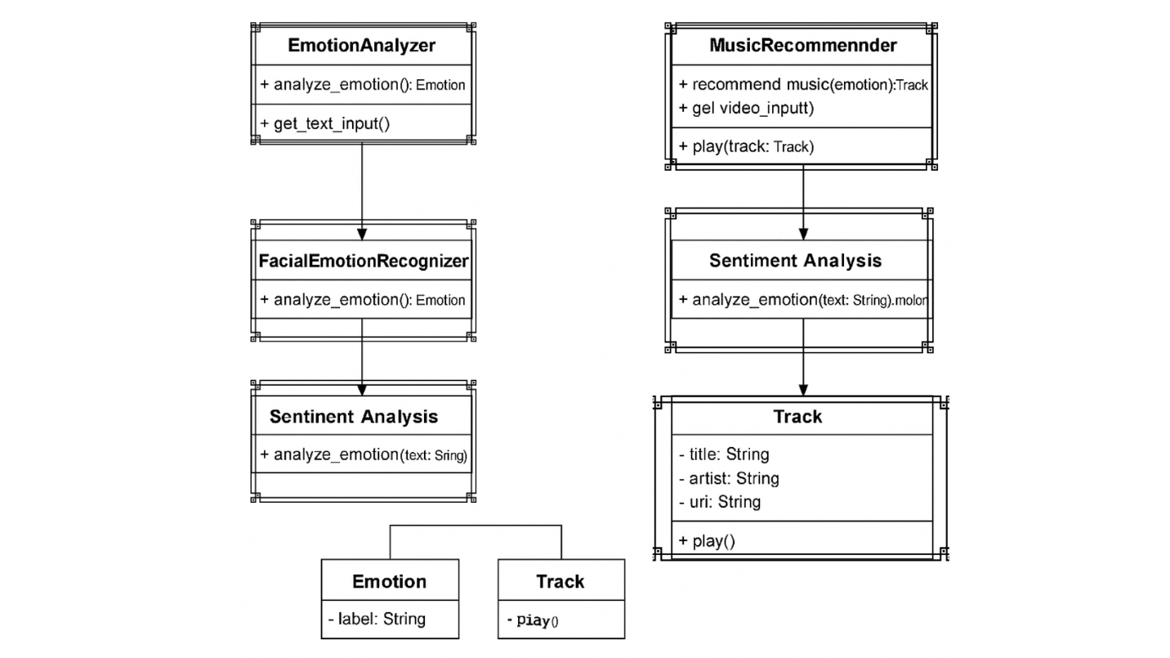

Figure : sample 2

* + 1. Activity Diagrams

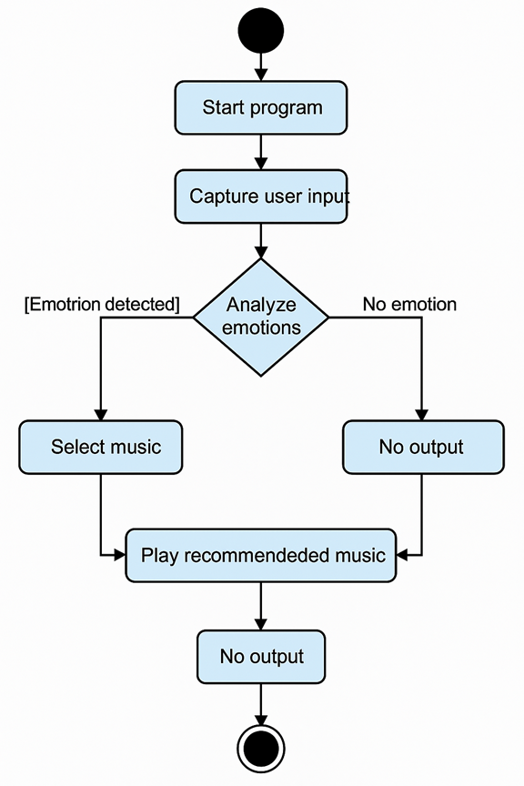

Figure : sample 3

* + 1. Sequence Diagram

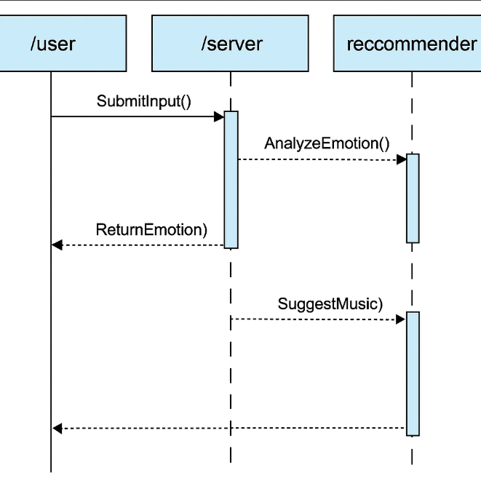

Figure : Sample 4

* + 1. Data Architecture

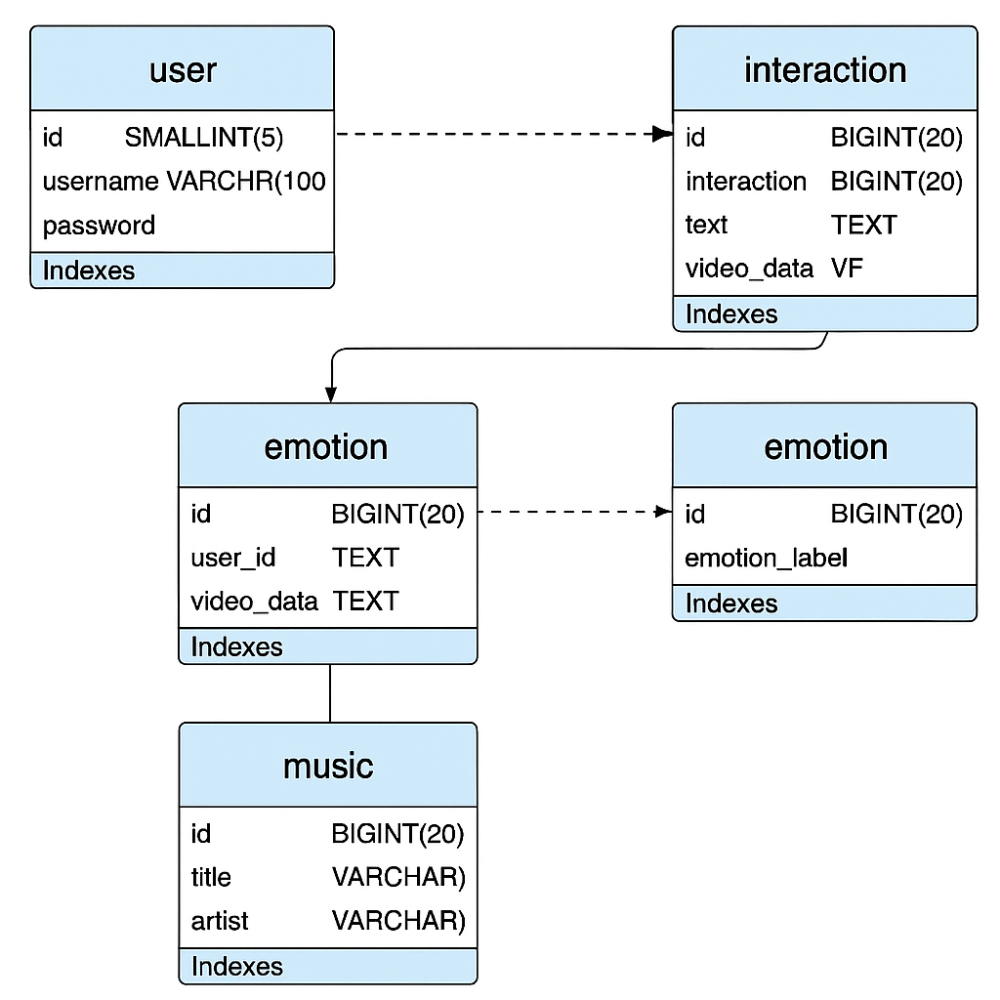

Figure : Sample 5

1. User Interface
   1. UI Description

User interface (UI) for this project is a web based and modern Frontend which offer an user interaction with a good user experience. The home page has a friendly hero area plus a glimmering animated heading highlighting project title — "AI Emotion Detection" accompanied with a button to get started. The layout features a dark theme with space-tech look, animated node connections in the background for a futuristic look.

As they access the application, users engage with only two subsystems: a real-time facial emotion recognition on the left and a chatbot interface on the right. Below those, the UI shows emotion-based music recommendation section that continuously changes song suggestions based on the detected emotions of the user. Each song card has a title, Song List Name, and a "Listen" button, giving the best seamless and friendly music discovery than an experience.

The UI caters for the fact that users can interact both with the visual and text-based emotion analysis, while the backend is making use of the data, will update them in real time. The interface is entirely web-based to avoid the need for any other software installation and to make it across the board and convenient to use.

* 1. UI Mockup

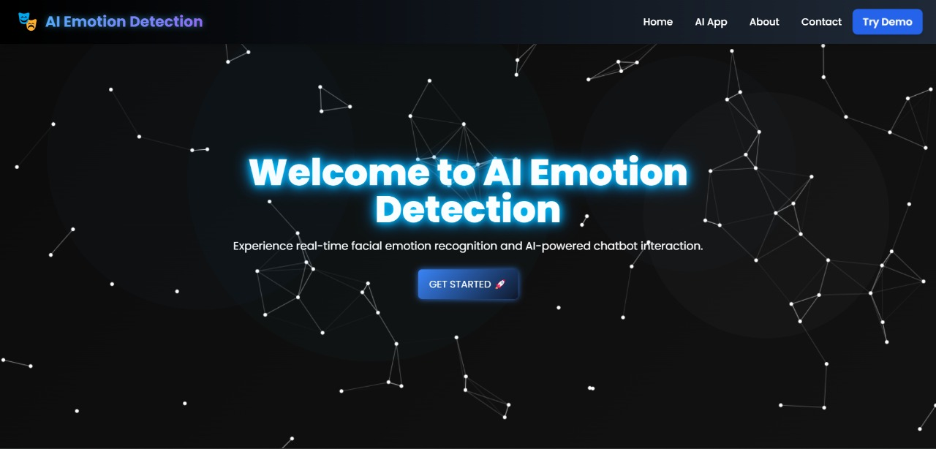

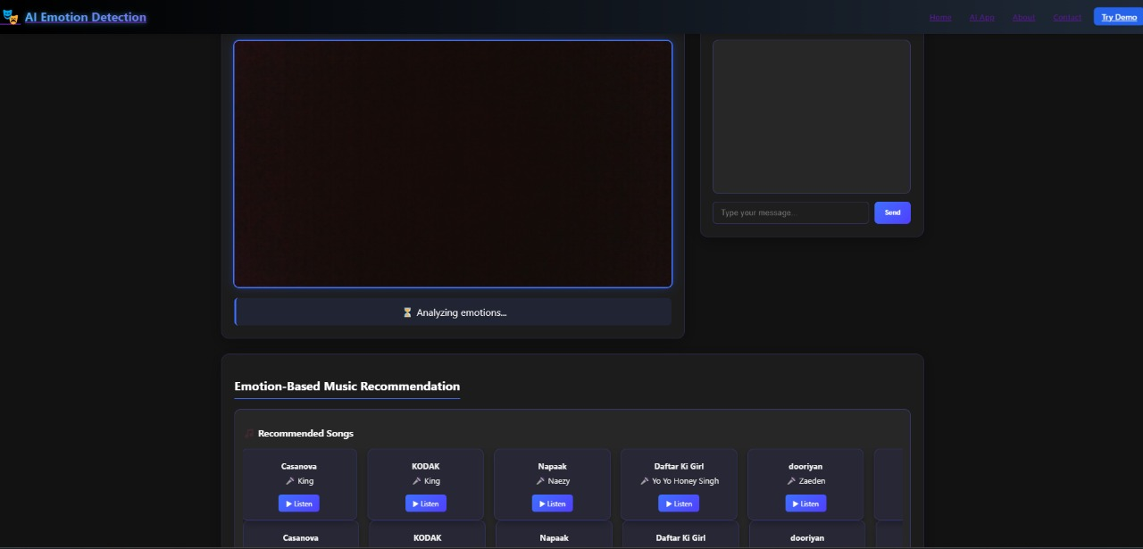

Figure : Sample 6

1. Algorithms/Pseudo Code OF CORE FUNCTIONALITY

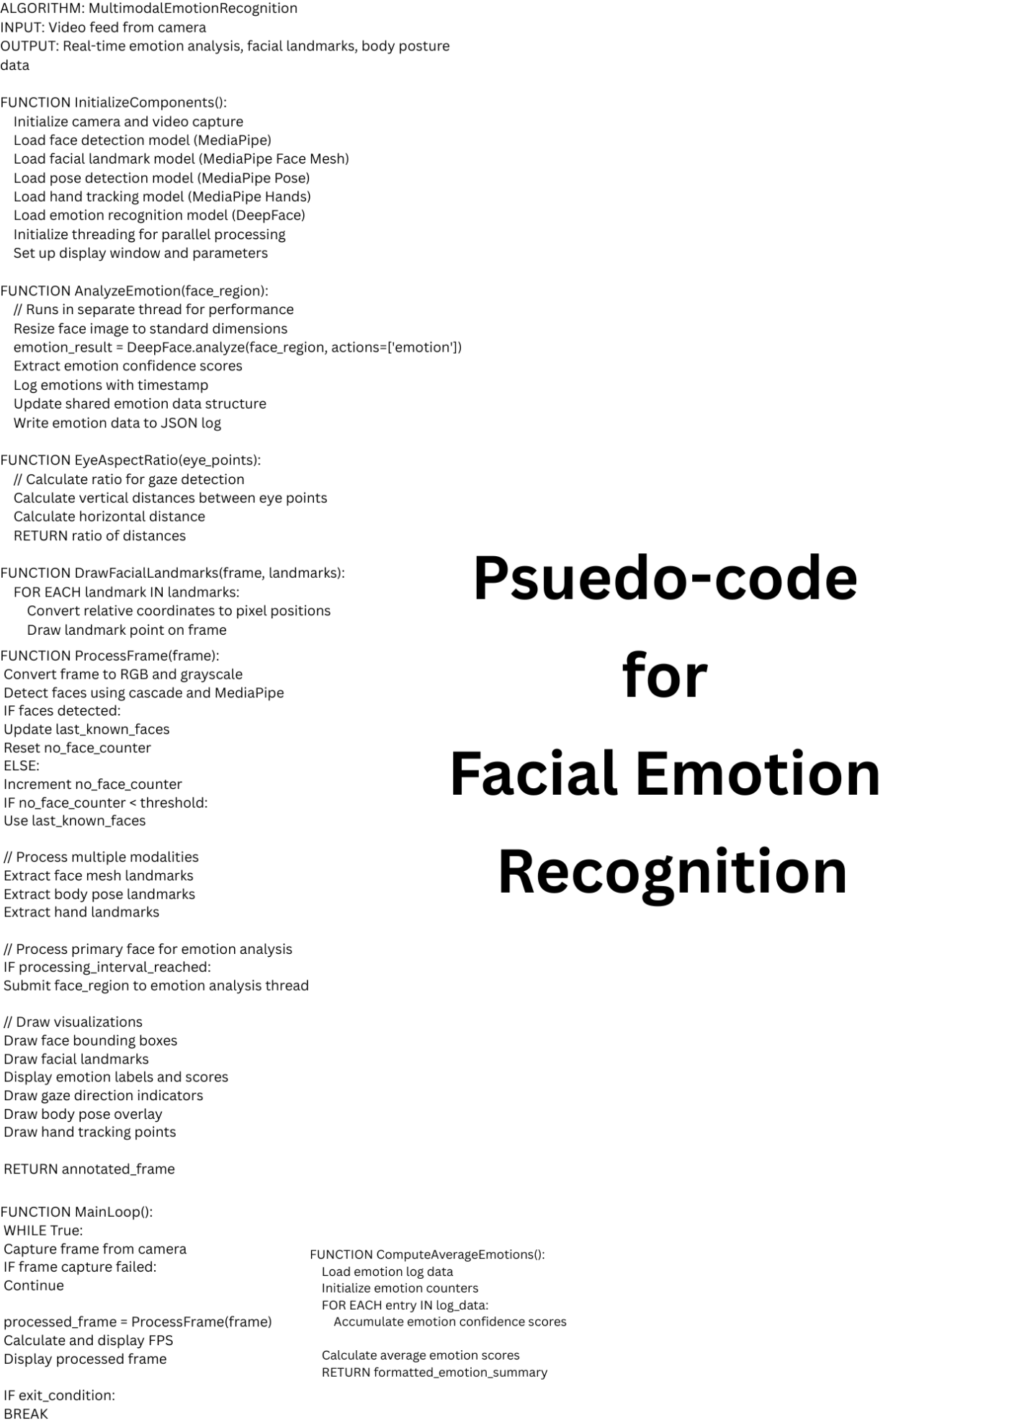

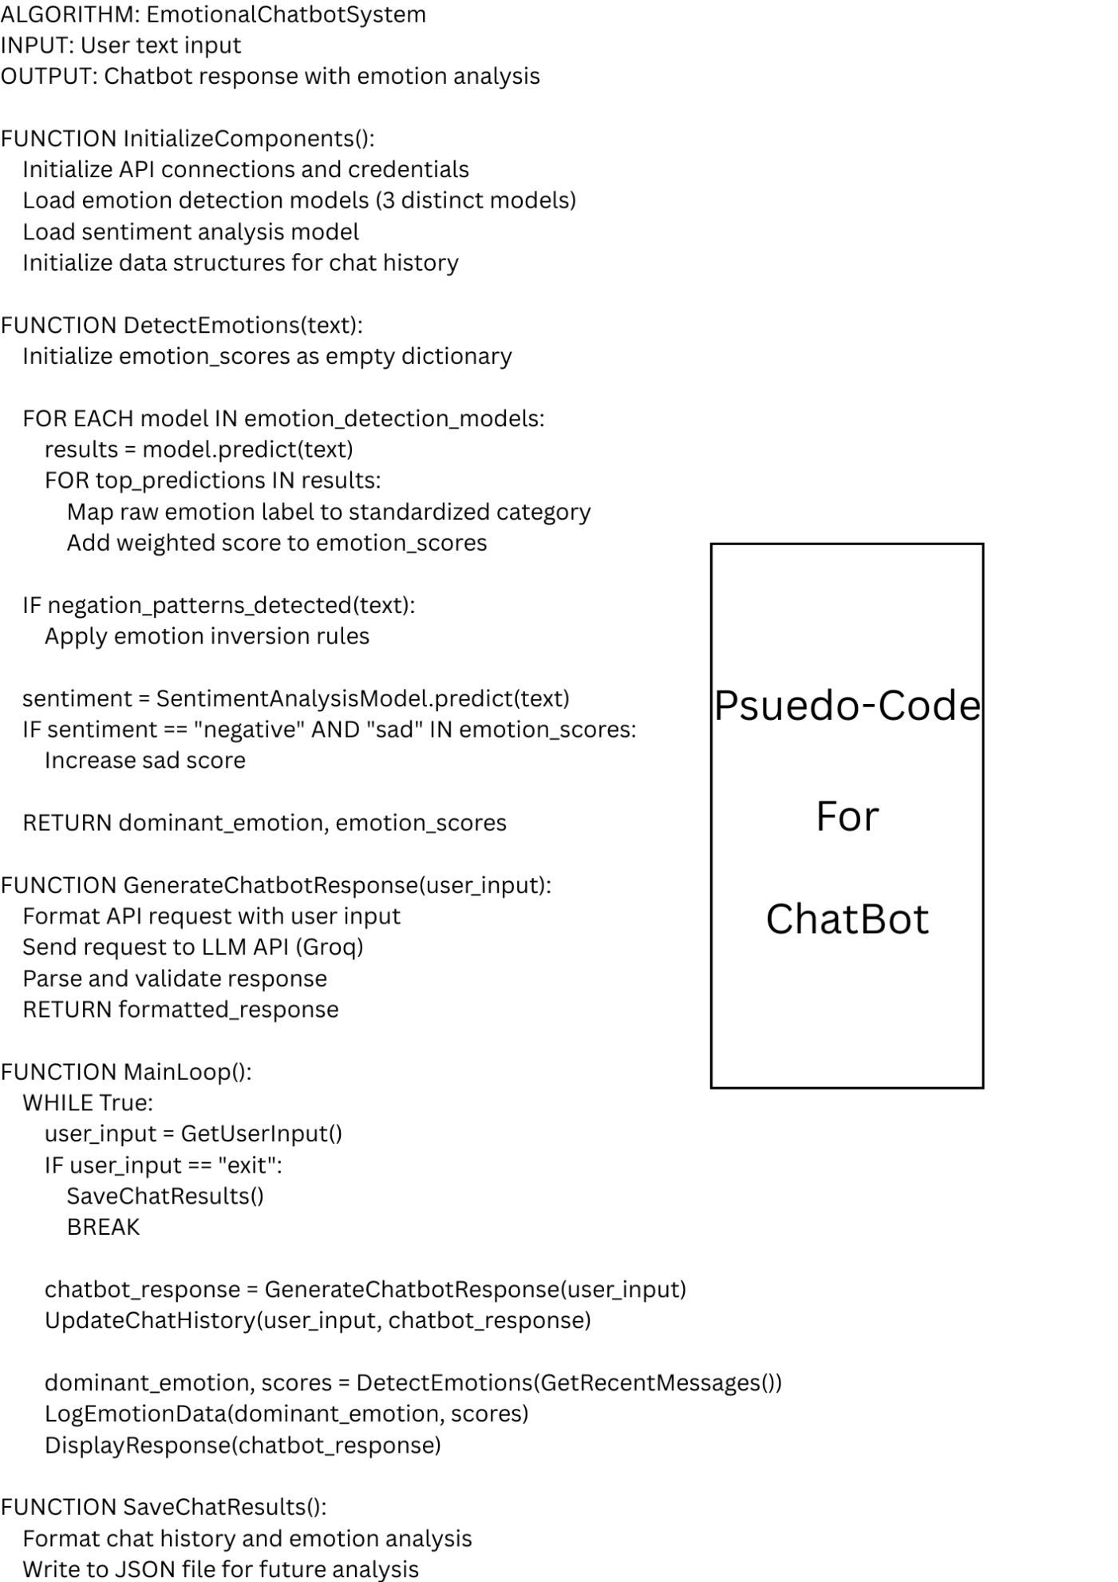

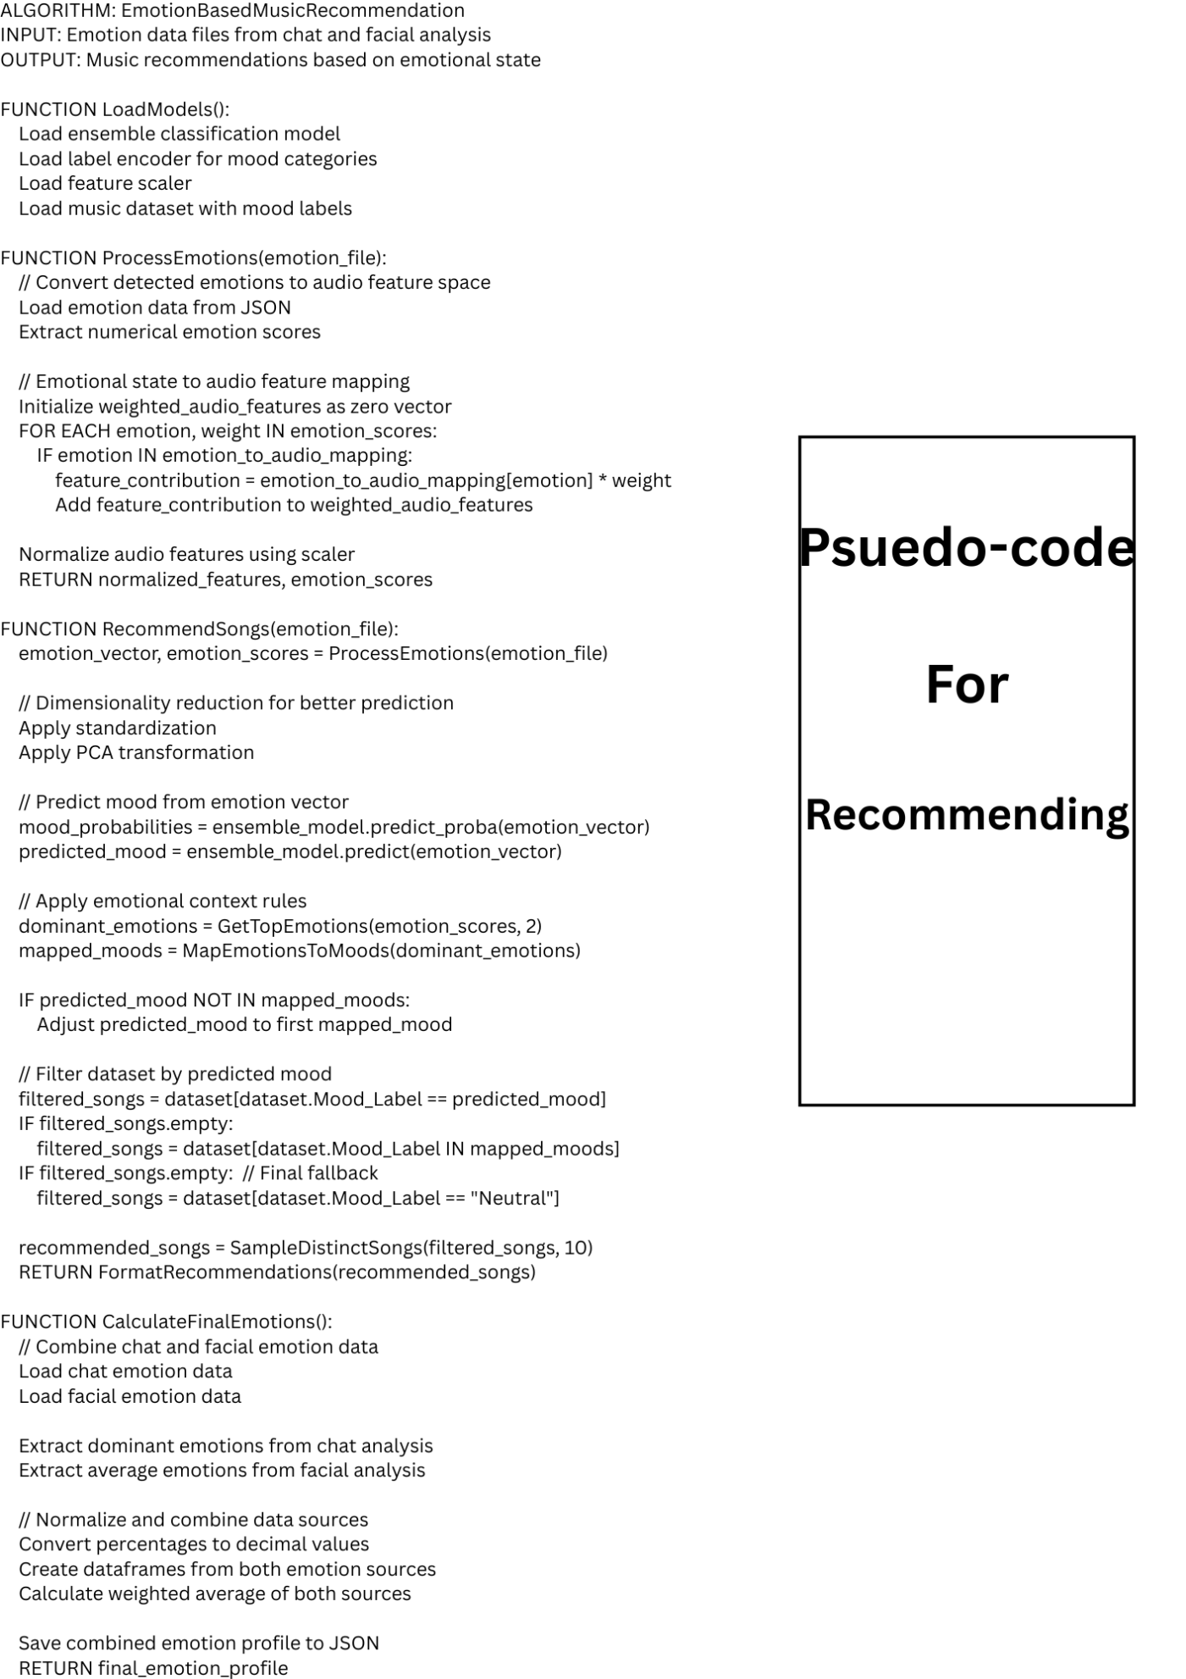

1. Project Closure

This section elucidates the overall lookup at the project and some of the future works that may enhance the solution.

* 1. Goals / Vision

Our original project aim was to create a live emotion-aware system that can recognize human emotions via facial expressions and spoken language to make music suggestions better suited to enhance the user emotional and mental well-being. Our first idea was basically to associate emotion detection with a basic music recommendation system. But with time passed by, the project went ahead, our aim went to a dual-mode emotion analysis system that detected by facial recognition, together with chatbot interface. The last solution does not only perceive considerably of emotions typographically and visually but also delivers personal music advises from now on all once in a while from a contemporary interactive web interface. This fits with our over-all goal of employing AI to augment psychological well-being with tech.

* 1. Delivered Solution

The delivered solution is a comprehensive web-based application. It consists of three core modules:

1. **Facial Emotion Recognition** using computer vision and deep learning techniques to capture real-time expressions via webcam.
2. **AI-Powered Chatbot** that interacts with the user in natural language, refining emotion classification through textual analysis.
3. **Emotion-Based Music Recommendation System**, which continuously analyzes detected emotions and dynamically recommends mood-enhancing songs.

The system is packaged as enterprise ready UI. It sports a homepage with animated entry point, dual pane for FER and chatbot interaction and a music section doubly updating by dynamically including the user’s ability to click "Listen" and engage with tracks. All background-processes -- emotion logging, averaging, and music selection are compiled into a single smooth and real-time user experience in app.py.

* 1. Remaining Work

While the project meets its intended functionality, several enhancements could further improve its effectiveness and scalability [17]:

* **Multilingual Chatbot Support** to interact with users in different languages and make it interactive worldwide.
* **Integration with Spotify/YouTube APIs [18]** to allow live streaming and real-time audio previews instead of placeholder buttons.
* **Improved Emotion Aggregation Models** to combine facial and textual emotion more accurately using weighted or ensemble models.
* **Mobile-Friendly Version** for increased accessibility across devices.
* **Emotion History Dashboard** for users to view their emotional trends over time and receive tailored wellness tips.
* **User Personalization Features** such as song feedback options or playlist creation based on mood profiles.

REFERENCES

1. A. Mahadik, S. Milgir, J. Patel, V. B. Jagan and V. Kavathekar, "Mood based music recommendation system," *International Journal of Engineering Research & Technology (IJERT)*, vol. 10, no. 6, 2021. [Online]. Available: <https://www.researchgate.net/publication/352780489_Mood_based_music_recommendation_system>
2. "Mood based Music Recommendation System," *International Journal of Engineering Research & Technology (IJERT)*. [Online]. Available: <https://www.ijert.org/mood-based-music-recommendation-system>
3. "Mood Sensitive Music Recommendation System," *International Research Journal of Engineering and Technology (IRJET)*, vol. 10, no. 8, 2023. [Online]. Available: <https://www.irjet.net/archives/V10/i8/IRJET-V10I871.pdf>
4. "AI Powered Musical Recommendation System," *International Journal of Research Publication and Reviews (IJRPR)*, vol. 6, no. 4, 2023. [Online]. Available: <https://ijrpr.com/uploads/V6ISSUE4/IJRPR41504.pdf>
5. J. Reddington, "The Inner Workings of Spotify’s AI Powered Music Recommendations," *Medium*, May 2023. [Online]. Available: <https://medium.com/beyond-the-build/the-inner-workings-of-spotifys-ai-powered-music-recommendations-how-spotify-shapes-your-playlist-a10a9148ee8d>
6. T. Babu, R. R. Nair and G. A., "Emotion-Aware Music Recommendation System: Enhancing User Experience Through Real-Time Emotional Context," *arXiv preprint*, 2023. [Online]. Available: <https://arxiv.org/abs/2311.10796>
7. E. Jing, Y. Liu, et al., "Emotion-aware Personalized Music Recommendation with a Heterogeneity-aware Deep Bayesian Network," *arXiv preprint*, 2024. [Online]. Available: <https://arxiv.org/abs/2406.14090>
8. S. Kambham, H. Jhonson and S. P. R. Kambham, "Emotion Detection and Music Recommendation System," *arXiv preprint*, 2025. [Online]. Available: <https://arxiv.org/abs/2503.20739>
9. Y. Taigman, M. Yang, M. A. Ranzato, and L. Wolf, “DeepFace: Closing the Gap to Human‑Level Performance in Face Verification,” in *Proc. IEEE CVPR*, 2014, pp. 1701–1708. [Online]. Available: <https://www.cs.toronto.edu/~ranzato/publications/taigman_cvpr14.pdf>
10. “Facial Action Coding System,” *Wikipedia*, Apr. 2025. [Online]. Available: <https://en.wikipedia.org/wiki/Facial_Action_Coding_System>
11. “OpenCV,” *Wikipedia*, Apr. 2025. [Online]. Available: <https://en.wikipedia.org/wiki/OpenCV>
12. J. Devlin, M.-W. Chang, K. Lee, and K. Toutanova, “BERT: Pre‑training of Deep Bidirectional Transformers for Language Understanding,” in *Proc. NAACL‑HLT*, 2019, pp. 4171–4186. [Online]. Available: <https://aclanthology.org/N19-1423.pdf>
13. S. Loria et al., “TextBlob: Simplified Text Processing,” *TextBlob 0.19.0 Documentation*, Read the Docs. [Online]. Available: <https://textblob.readthedocs.io/>
14. S. U. U. K. Zheng et al., “A Survey of Music Recommendation Systems,” *ACM Digital Library*, 2023. [Online]. Available: <https://dl.acm.org/doi/10.1145/3671151.3671243>
15. Spotify, “Spotify Million Playlist Dataset Challenge,” *AIcrowd*, 2018. [Online]. Available: <https://www.aicrowd.com/challenges/spotify-million-playlist-dataset-challenge>
16. J. Sutherland and K. Schwaber, *The Scrum Guide*, ScrumGuides.org, 2020. [Online]. Available: <https://scrumguides.org/docs/scrumguide/v2020/2020-Scrum-Guide-US.pdf>
17. D. Sánchez‑Moreno, Y. Zheng, and M. N. Moreno‑García, “Time‑Aware Music Recommender Systems: Modeling the Evolution of Implicit User Preferences and User Listening Habits,” *arXiv preprint arXiv:2008.11432*, Aug. 2020. [Online] Available: <https://arxiv.org/abs/2008.11432>
18. W. Bendada, G. Salha‑Galvan, T. Bouabça, and T. Cazenave, “A Scalable Framework for Automatic Playlist Continuation on Music Streaming Services,” *arXiv preprint arXiv:2304.09061*, Apr. 2023. [Online] Available: <https://arxiv.org/abs/2304.09061>